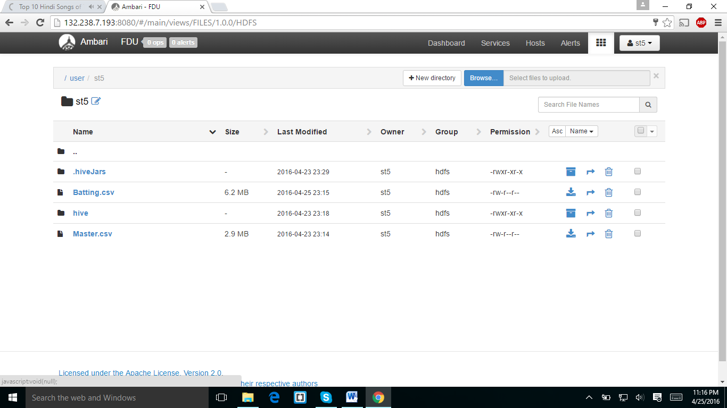

I downloaded the master.csv file from web campus and uploaded to my folder using ambari.

In the below screen shot I run the pig script which was given in home work document and I got the below results.

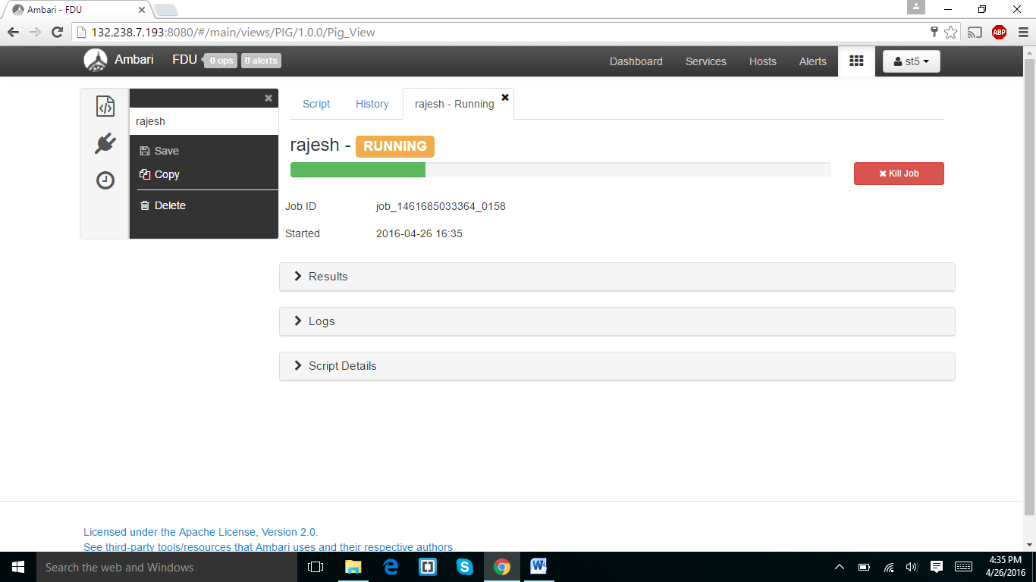

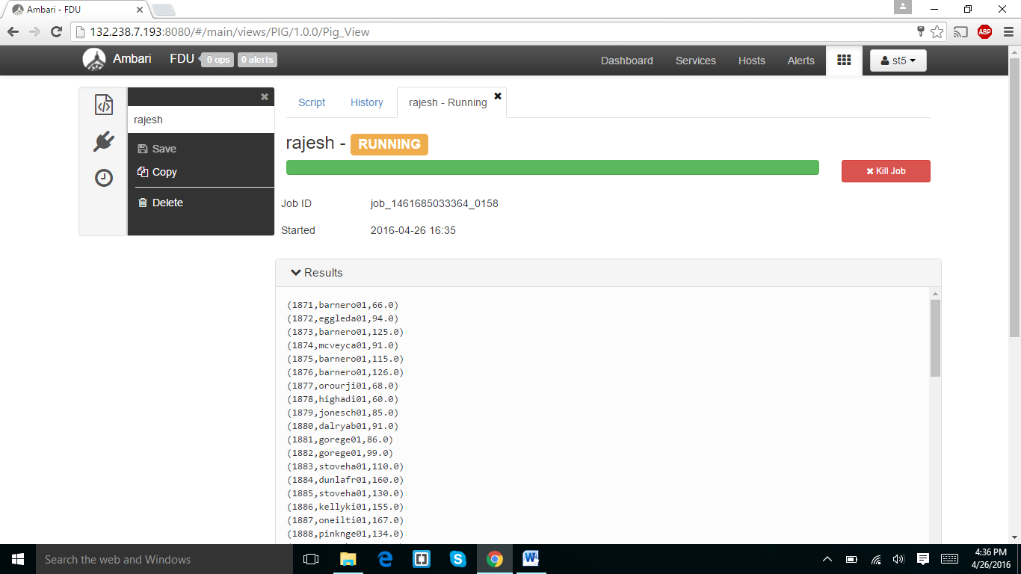

I downloaded the log files and results and the screen shots displayed below.

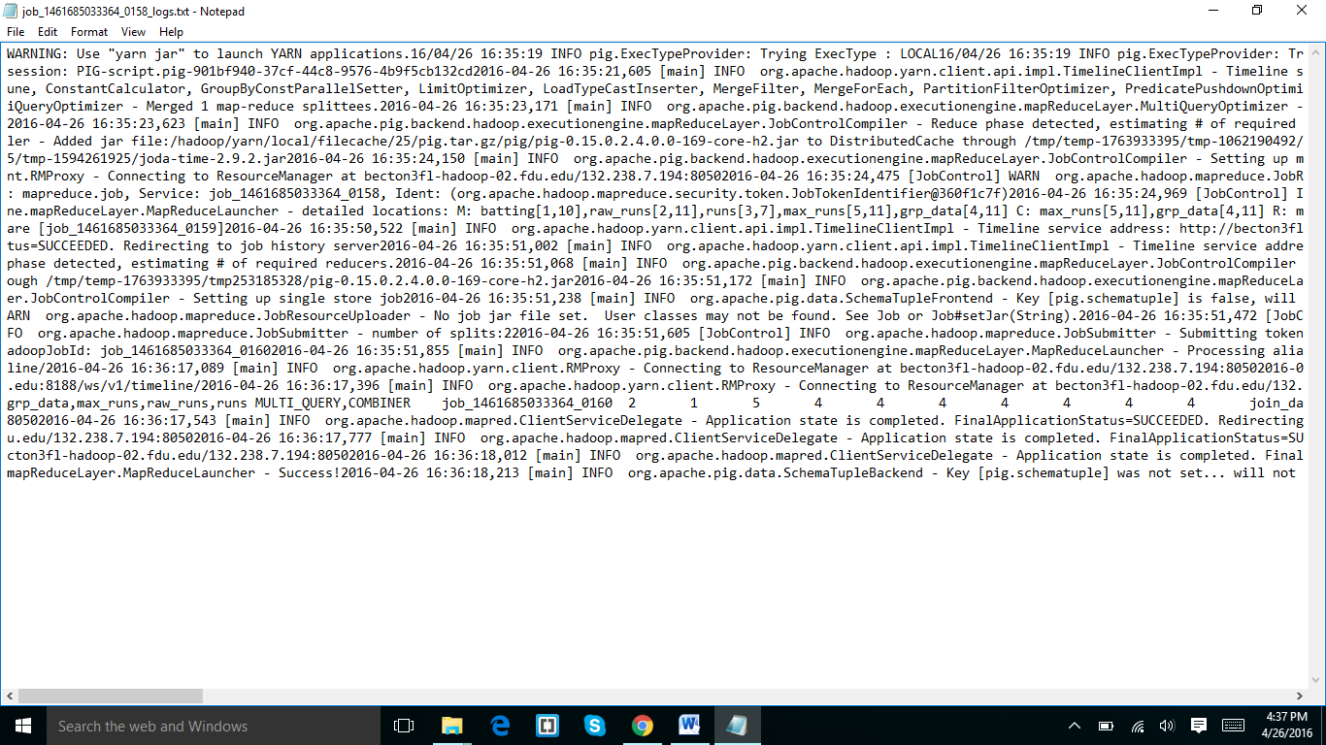

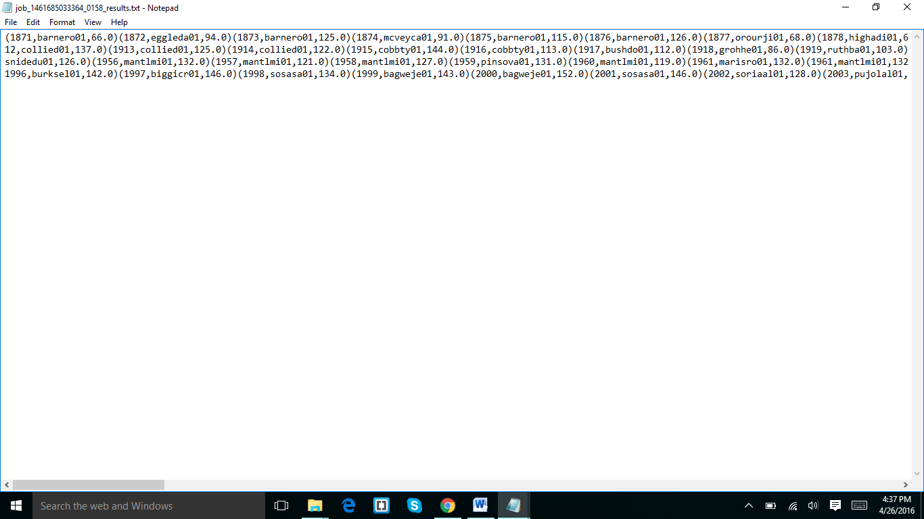

14 ANSWER:

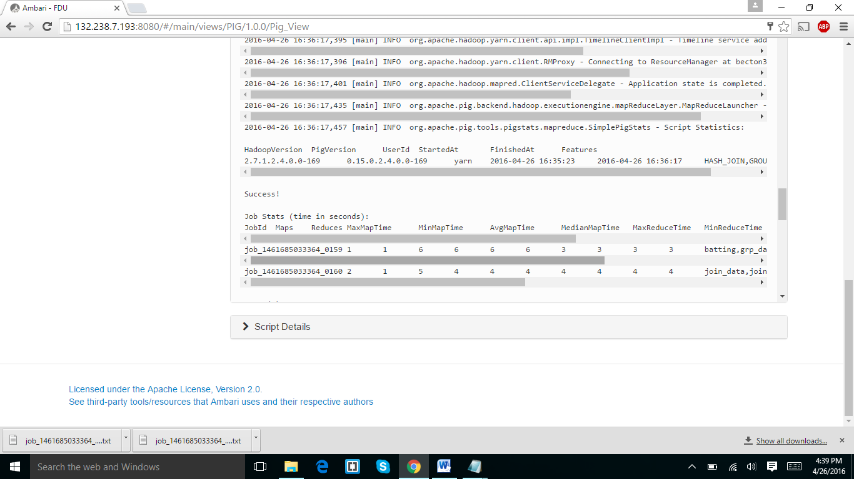

It started at 04:35:23 and end at 04:36:17. It took about 11 minutes forty seconds

I run the same script on tez but it has given some errors.

EXTRA CREDIT ASSIGNMENT:

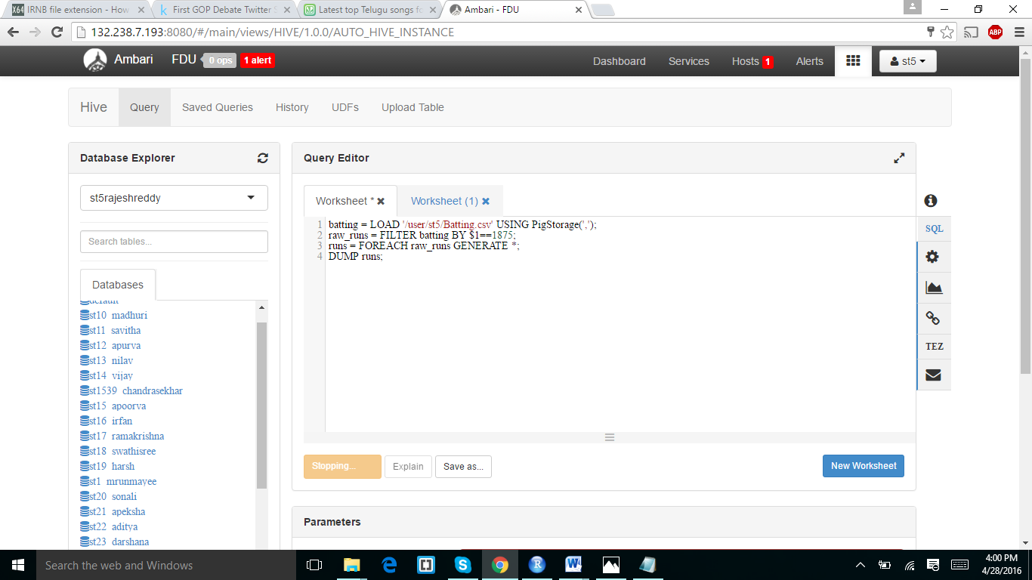

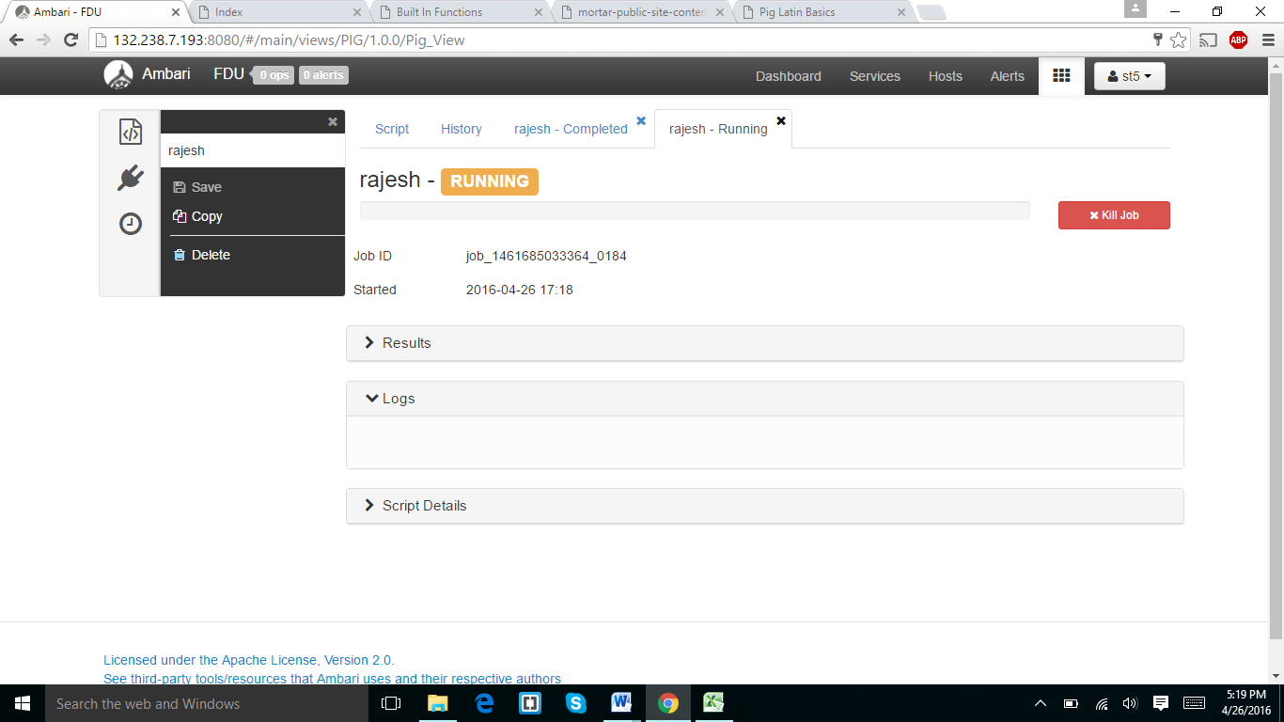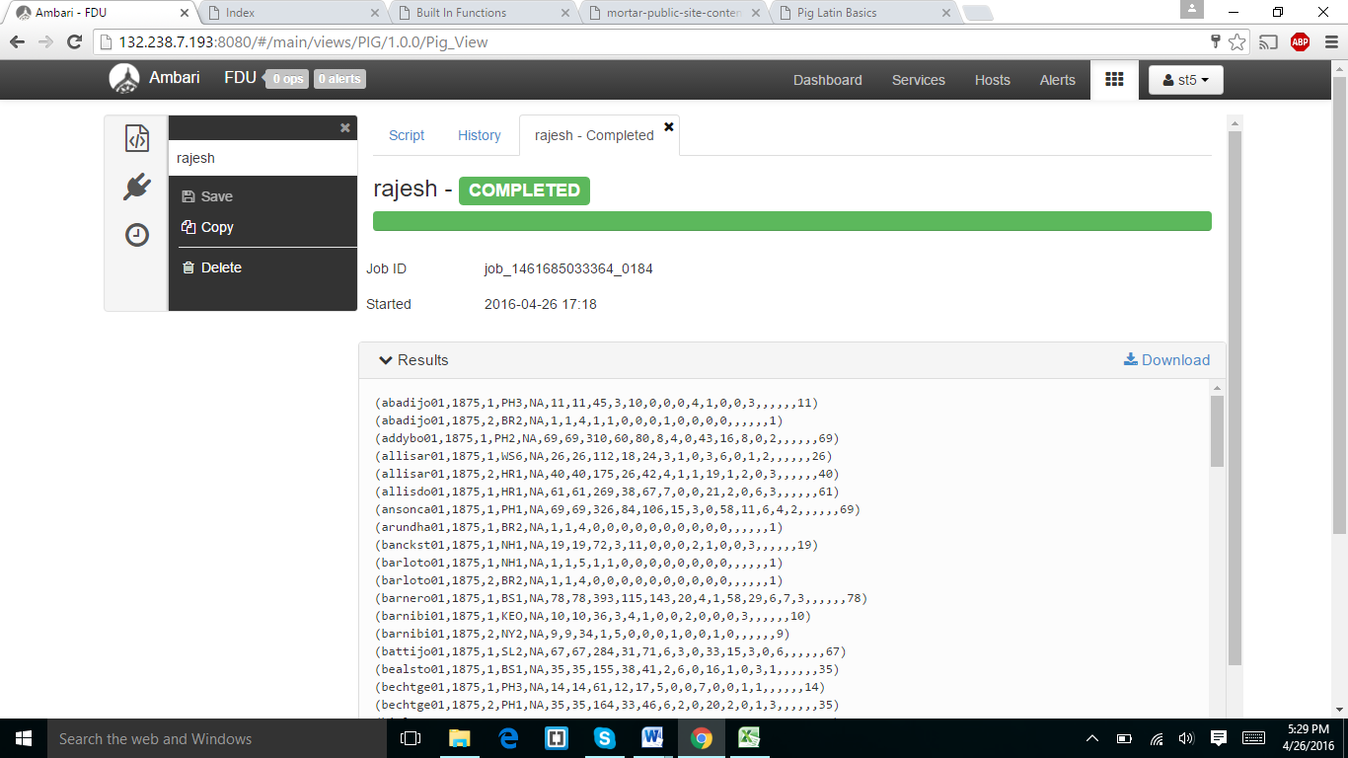

I have used the the below command and run it I forget to take screen shot of the code

Code=(batting = LOAD '/user/st5/Batting.csv' USING PigStorage(',');

raw_runs = FILTER batting BY $1==1875;

runs = FOREACH raw_runs GENERATE *;

DUMP runs;)